**Quantifying sediment and potential contaminant dynamics of dam removal on the Malibu Creek, using field measurements, observations and hydrological and sediment models.**

Ghosh, Adit ^*

* Geological Sciences, California State University, Northridge

^ adit.ghosh.605@my.csun.edu

Spring 2020

**I. Abstract**

As more and more dams are rendered obsolete due to sediment build up over the decades, the issue of how to mitigate, remove and restore original natural riparian corridors has become ever more important. In this study we use field observations, mathematical models and laboratory contaminant tests1 in order to predict the fate of the Malibu Creek ecosystem after the removal of the Rindge Dam. We use velocity observation, predict discharge and sediment fluxes after tentative dam removal. While contamination tests were inconclusive, we determine that the quality of sediment discharge will be greatly changed by the removal of the dam, altering the current natural and human ecosystem. We conclude that sediment dredging before dam removal is essential in order to prevent adverse consequences such as changes in sediment type at Malibu beach which lies on the estuary of the Malibu Creek system.

1Unable to perform laboratory test due to COVID emergency

**II. Introduction**

1. **Impact of Dams**

It has long been known that dams alter the physio-chemical fabric of an ecosystem (Baish, 2002). Dams cause the retardation of the natural flow velocity of water, which results in the settling of sediments including dissolved and colloidal phase particles. Previous studies on large dams in the Colorado River (Baish, 2002) have indicated that dams greatly alter sedimentation. Given enough time these Dam Deposited Sediments (DDS) build up in the dams stagnant reservoir causing a loss of capacity which ultimately rendering the dam incapable of storing water. The early 20th century witnessed the peak of dam construction in the United States. A century later, many of those structures have started to lose capacity, and some like the Rindge Dam on the Malibu Creek have been saturated with sediment, to the point where they no longer perform their intended function.

1. **Background on Rindge Dam and Dam removal**

Rindge Dam was built in 1926 as a reservoir of water for irrigation. It is a 102 foot tall structure, 140 ft wide steel reinforced concrete dam. The high sedimentation rate of the Malibu creek watershed soon rendered the dam obsolete in little under 30 years by 1955 so much sediment had accumulated that the reservoir could no longer serve its intended purpose of storing water and has been rendered useless ever since. It impounds around 800,000 cubic feet of sediment (Dallman, 2002).

1. **Pros and cons of dam removal**

The construction of the rindge dam severely obstructed the migration of steelhead trout (Dagit, 2009). As a result environmentalists have long argued for the removal of this dam in order to restore the migration route of the trout. Additionally, dams starve downstream beaches of sediment. Rindge dam sits upstream from Malibu beach, a popular tourist spot in the Greater Los Angeles Area. Removing the rindge dam might allow for greater sediment flux to Malibu Beach.

Opponents of dam removal have argued that the removal of the dam might cause a greater risk of floods downstream in addition to debris and mud flows in the posh community of Malibu. Additionally, if the built up sediment is contaminated, it will have to be removed and stored elsewhere. This is problematic because the dam is located in extremely difficult terrain with 50 to 80 degree slopes. This means that dredging and removing the dredged sediment by trucks will be extremely challenging. These trucks will have to use Malibu Canyon Road, which is a one lane winding mountain road which experiences intense traffic over the weekends. The steep sandstone lithology also makes it prone to rock falls. If the sediment is not contaminated and is allowed to naturally erode, the resulting flow might erode anything from mud to pebble and boulder sized particles depending on flow strength and deposit them to Malibu beach. This is problematic because what makes Malibu Beach a prime location for tourists, surfers and realtors is it’s picturesque sandy beach.

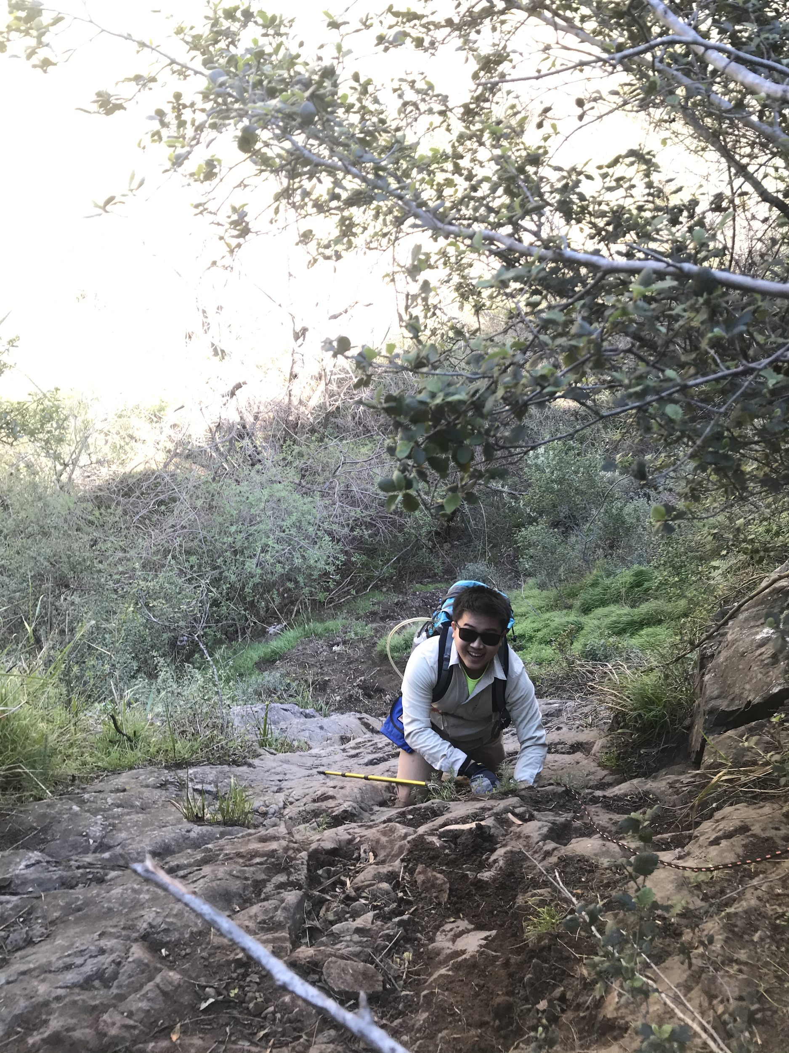

**Figure 1:** Access to Rindge Dam from Malibu Canyon Road presents its own set of challenges, such as two repelling sections over slippery sandstone.

1. **Sediment Flux Before and After Dam removal**

Sediment fluxes change due to the construction of dams. Slowing of water causes suspended particles to deposit due to waning flow behind the structure. At present, the dam is still in place. The concrete structure does not permit erosion on the downstream section. Current sediment fluxes due to the existing dam were initially intended to be analyzed by Total Suspended Sediment (TSS). Assuming a future scenario where the concrete structure is removed, Malibu Creek will flow over sediments which are much more friable than concrete and easily erodible. In order to estimate sediment fluxes in this hypothetical scenario, we use mathematical models to estimate TSS when the dam wall is removed and sediment is allowed to be eroded on its inclined face.

1. **Potential Contaminants**

The presence of agricultural and residential activity in the upper Malibu watershed could have resulted in the contamination of DDS over the last century. Frequent fire regimes in this region of Southern California could have resulted in the contamination of the DDS with Poly Aromatic Hydrocarbons (PAH’s), a known carcinogen (Source). When the Rindge dam is removed, without manually removing backed up DDS, Malibu Creek will return to the original base level flow present prior to the establishment of the Dam in 1926 due to base level equilibrium. This will result in the incision of the DDS. These incised sediments will be deposited downstream, in what is the beach town of Malibu, where the Malibu Creek forms an estuary. The estuary mouth forms Malibu Beach, an important tourist attraction of the Los Angeles Area.

In this study we attempt to investigate for the presence of Mercury and PAH contamination in DDS of Rindge Dam on Malibu Creek. We then utilize current sediment flux rates to calculate the rate of DDS incision and erosional rate. Using the erosional rate, we calculate the flux of potential sediments and contaminants to the Malibu beach.

**III. Methods**

1. **Assumptions**
   1. **Flow, geomorphic and sedimentological assumption**

We assume that when the concrete dam wall is removed, sediment will be eroded in a vertical fashion as shown in figure 2. We disregard the buoyancy of falling water and drag due to air on falling water.

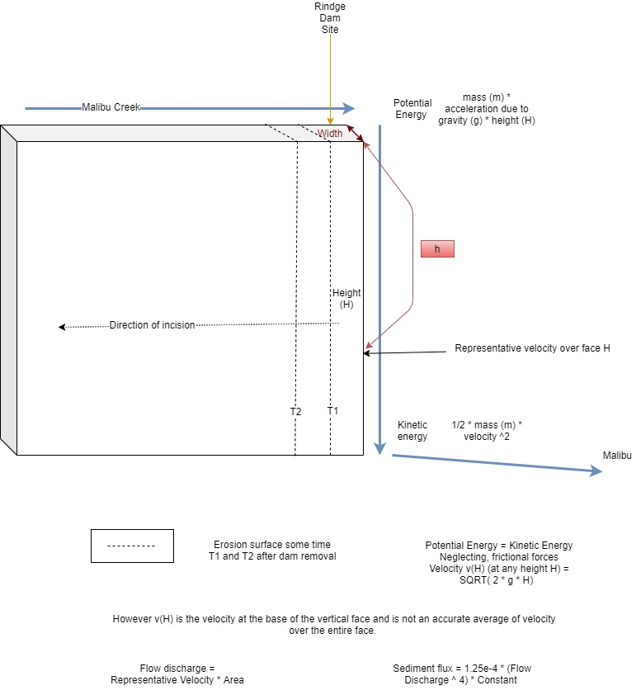

Figure 2: Diagram showing the velocity and sediment flux gradient over the face of the dam.

* 1. **Contaminant assumptions**

We assume the contaminant gradient to be vertically constant. This implies that the contaminant supply to the system has remained constant to the basin since the creation of the dam. We presume that no significant decay of sediment occurs over the span of a century. This assumption is not necessarily valid for volatile compounds such as Monomethyl mercury. Only coring of the sediment can truly determine if the entirety of the sediment is contaminated. However, if we find very high concentrations of contaminants in the top sediment layers, this might indicate a very polluted catchment and imply utmost need to core bottom sediment.

1. **Current Sediment Flux in Water Column**

**Field Sampling of TSS**

TSS was sampled at two locations. The Rindge Dam location represents the total flux of sediment entering the sediment reservoir. The Rindge Dam location represents the sediment flux just before the cliff of the dam.

1. **Calculation of Sediment Flux post removal** 
   1. **Mathematical Calculation of Volume Flux**

The velocity of water falling over the dam is calculated using the relation between gravitational potential energy and kinetic energy by using the equation

Weight of falling water = m (kg)

Acceleration due to gravity = g (m/s2)

Velocity of water at the bottom of dam = v (m/s)

Potential Energy at top of Dam = Kinetic Energy at bottom of Dam

m * g * h = 0.5 * m * v

Therefore,

v = (2 * g * h) ^ 0.5 (m/s)

However, this velocity is only reached at the bottom of the dam. In order to get a more representative velocity, we simply use the arithmetic average between the starting velocity, which is assumed to be 0 m/s, at the top of the dam and the velocity at the bottom of the dam.

We observationally estimated the flow area (A) over the first flood gates of the dam. This is best estimated around 2.34 m2.

We then estimate the Discharge volume flux (Q) to be

Q = A * v (m3/s)

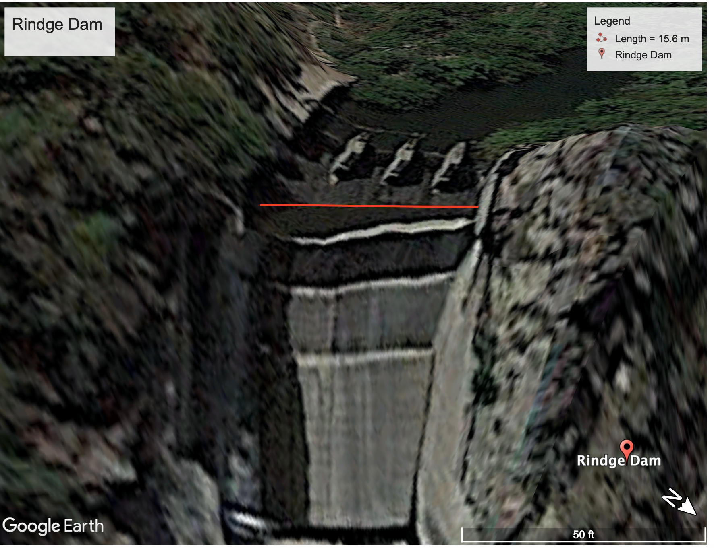

**Figure 3:** Determining flow area over structure using google earth.

**Figure 4:** Field visual check to determine relative accuracy of Area calculation from Google Earth. There are a total of 5 gates. 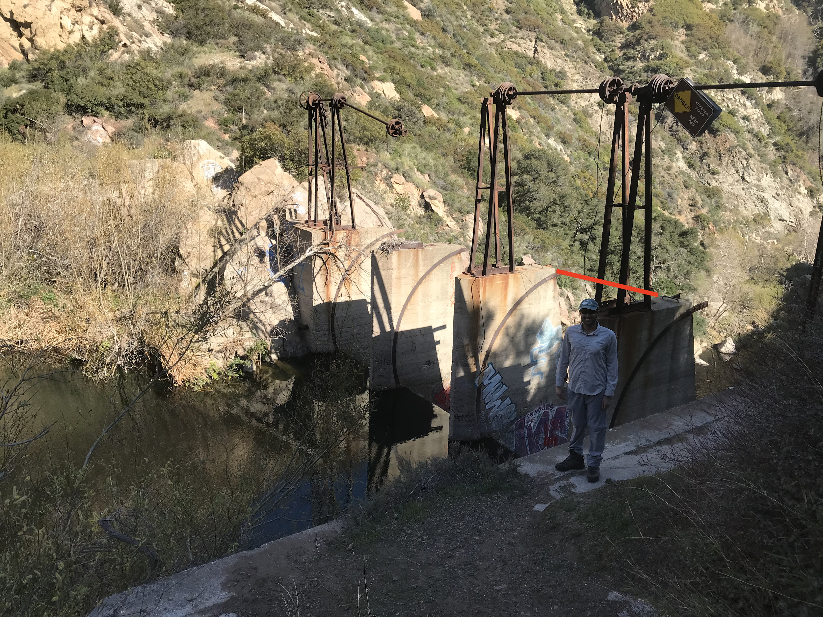

* 1. **Calculation of Sediment flux from Volume Flux**

Using volume flux, we then calculate sediment flux using the following equation supplied by USGS (Gelfenbaum, 2011)

S = (1.25*(10^(-4))) * (Q^4) * K (m3/s)

Where K is a unit conversion factor = 0.0864

Additionally, we assume a linear relation between sediment flux and contaminant quantity.

1. **Contamination**
   1. **Poly Aromatic Hydrocarbon (PAH) in sediment**

PAH samples were sampled using PAH clean techniques. One PAH sample was collected at Rindge Dam representative of the sediment contamination of the sediment buildup. PAH’s were to be analyzed using gas chromatography at the Organic Geochemistry Lab at CSUN.

* 1. **Mercury flux in water**

We used trace metal clean techniques to sample for both total Mercury (HgT) and MonoMethyl Mercury (MeHg). Two water samples were collected. The site at Puma Bridge represents the volume flux of Mercury species entering the Rindge dam sediment reservoir. The Rindge Dam sample represents the flux of Mercury species currently in the water column at rindge dam. We assume a linear relation between Mercury in the water column and Mercury in sediment. These samples were then analysed on a Total Mercy and Monomethyl Mercury analyser at the Water Lab in CSUN.

**IV. Result**

1. **Sediment Flux**

**a. Current sediment flux calculated**

|  |  |  |  |  |  |
| --- | --- | --- | --- | --- | --- |
| **Sample** | **Maximum Velocity (v_max)**  **(m/s)** | **Average Velocity (v_avg)**  **(m/s)** | **Area estimation (A)**  **(m^2)** | **Discharge Volume (Calculated) (m^3/s)** | **TSS**  **(Calculated) (Mega gram/day)** |
| Puma Bridge* | 2 | 1 | 30 | 30 | Inconclusive due to COVID-19 |
| Rindge Dam*  (Top of Rindge Dam) | 2 | 2 | 15.6 | 31.2 | Inconclusive due to COVID-19 |
| Base of Rindge Dam | 24.2487 | 12.1244 | 2.3400 | 28.3710 | Same as above Rindge Dam as no erosion over the concrete face of the dam. |

* * Visual estimation for velocity.

**b. Estimated Sediment flux after dam removal**

|  |  |  |  |  |  |
| --- | --- | --- | --- | --- | --- |
| **Sample** | **Maximum Velocity (v_max)**  **(m/s)** | **Average Velocity (v_avg)**  **(m/s)** | **Area estimation (A)**  **(m^2)** | **Discharge Volume (Calculated) (m^3/s)** | **TSS**  **(Calculated)**  **(Mega gram/day)** |
| Puma Bridge* | 2 | 1 | 30 | 30 | - |
| Rindge Dam*  (Top of RIndge Dam) | 2 | 2 | 15.6 | 31.2 | - |
| Base of Rindge Dam | 24.2487 | 12.1244 | 2.3400 | 28.3710 | 6.9972 |

1. **Contaminant in Malibu Creek System**

|  |  |  |  |
| --- | --- | --- | --- |
| **Sample** | **HgT** | **MeHg** | **PAH** |
| Puma Bridge | Inconclusive due to COVID-19 | Inconclusive due to COVID-19 | Inconclusive due to COVID-19 |
| Rindge Dam | Inconclusive due to COVID-19 | Inconclusive due to COVID-19 | Inconclusive due to COVID-19 |

**C. What quality of sediment will be transported to Malibu beach if the DDS is allowed to naturally erode?**

We use Hjulstrom’s diagram (Figure 2) in order to quantify the size and quality of sediment that will be eroded (Hjulstrom, 1935). Using our calculated average velocity of 15 m/s (1500 cm/s) we observe the relation between flow strength and clast size. The flow is strong enough to erode and transport everything from clay sized particles 0.001 mm in size to boulder clasts upto 1 m in size.

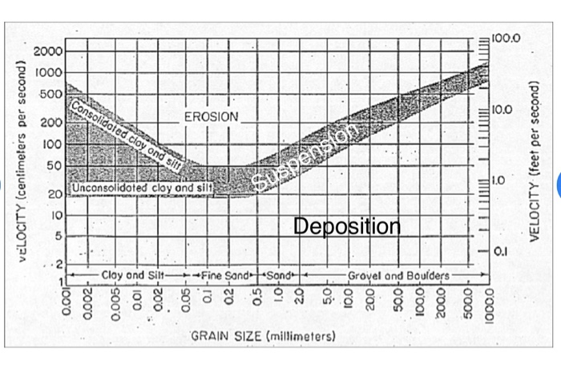

**Figure 5:** Hjulstorm’s diagram (Hjulstrom, 1935) indicating clasts size that correspond to calculated velocity.

**V. Discussion**

1. How does sediment flux change after dam removal?

Sediment flux after dam removal is estimated at 6.997 megagram/day. Lack of TSS analysis prevents us from comparing our theoretical sediment flux with the current sediment flux of the system.

1. Is the Malibu Creek system contaminated?

Our results were inconclusive as laboratory tests were impossible to carry out due to the COVID-19 pandemic shutdown. It is impossible to visually determine PAH and HgT or MeHg contamination. Analysis of these contaminants is time sensitive and would require another sample collection expedition.

1. Is the sediment behind the dam a potential contamination bomb?

While the COVID-19 outbreak prevented us from analyzing contamination of our sediments, we can draw certain conclusions based on certain assumptions. If the DDS is contaminated, and if this contamination is present vertically throughout the sediment, one could expect a rapid rise in contamination downstream at Malibu Beach where this sediment will eventually be drained due to the rapid increase in sediment erosion.

1. Will Malibu remain a Sandy beach if sediment is naturally allowed to erode?

No. Removal of Rindge Dam without sediment removal will result in a drastic change in sediment quality downstream at Malibu Beach. While the transported unconsolidated clay and silt will remain in suspension phase due to wave and tidal energy, medium sand to cobbles/boulders will be deposited at or near Malibu Beach. This will significantly deteriorate the appeal of Malibu Beach especially for surfers and beach goers. Additionally, a unique property of unconsolidated clay and silt allows for the transport of rip up clasts of pebble and boulder sized clay and silt instead of unconsolidated clay and silt particles. This would potentially be an issue as wave energy might not immediately transform these to dissolved phase.

1. Should the sediment behind the dam be dredged out?

Yes. The dredging of Rindge dam is essential if the negative effects of dam removal are to be mitigated. Even if the DDS is not contaminated the quality of eroded sediment will adversely affect the Malibu Beach ecosystem.

1. Lesson for dams in other high sediment flux areas such as the Himalayas

The last decade saw a number of large scale damming operations in the developing world. Many of these dams were built on high sediment and high discharge rivers such as a number of Himalayan rivers like the Teesta, Ganga, Brahmaputra/Tsang-po, Indus and Alaknanda (Garg, 2020). These rivers have created the world’s largest delta on planet earth with sediment derived from the Himalayan catchment. The Himalayas are a young mountain range and are very sediment laden as a result. These newly constructed Himalayan dams are thus destined to ultimately meet the same fate as the Rindge Dam. Even Teri dam on the Ganga, the highest dam in India, is estimated to reach its useful life in 160-180 years (Garg, 2020).

**Figure 6:** One of the many cascades of dams constructed on the River Teesta in the Eastern Himalayas as seen in May (just before the monsoons) when the river is at its lowest level. Observable in light color on the left bank are slope instability such as slumps and slides that might quicken the sedimentation process.

The river Teesta carries one of the highest sediment loads in the world. It originates close the third highest peak in the world Mt. Kanchendzonga. There are currently four separate commissioned dams and one under construction on the main Teesta channel itself with, not including tributaries, with more proposed (Bhatt, 2017). The same challenges of steep and rugged terrain, high sediment flux and potential community impact present themselves here.

The problems and challenges faced by the landscape, ecology and communities of Malibu are a clear indication of what will be faced by future generations in Himalayan foothills long after the Himalayan dams have lived their functional lives. Thus, the ultimate cost of dam construction might not be fully realized until years after construction and not until the dams have served their full purpose. Whether developing countries choose to follow the footsteps and mistakes of the developed world will decide the fate of local communities for generations to come.

**VI. Further Investigations**

This study attempts to analyze the very complex issue of dam removal. It investigates one, overly simplified scenario. In order to further gain a further understanding, one will need to analyze all the other geomorphological scenarios of sediment erosion. The complex science of dam removal geomorphology is a young one, and one that has only recently been appreciated. One can only speculate the nature of cohesion of the DDS until a representative core is taken. While the COVID-19 emergency has delayed contaminant assessment of the DDS, a better determination of contaminants would require a representative core. Incorporating the course of the Malibu river from Rindge Dam to Malibu Beach in our model will give us a better understanding of, and determine if, pebble-cobble-boulder sized clasts will be eroded all the way to Malibu Beach. Our calculations for sediment flux do not account for the new availability of unconsolidated sediment and is probably an underestimate. Another significant effect of soft dam sediment is the increased risk (greater intensity of shaking as compared to hard ground) they pose during the occurrence of an earthquake. Both Rindge Dam and the many Himalayan dams lie in the most seismically active areas of the planet. Mega earthquakes in the Eastern Himalayas can produce upto 20 m of ground motion (Hough, 2009). Liquefaction and movement of soft dam sediment compounded by intense shaking might result in dam collapse which would lead to liquified mud and debris flow and potentially contaminated sediment flow. Having a cascade of dams, as on the Teesta, might complicate this problem. It is thus imperative that we study the dynamics of dam sedimentation through field, laboratory and fluid and sediment modelling.

**VII. Conclusion**

In conclusion, natural erosion of the Rindge Dam site will result in adverse effects. Increased flow velocity will result in greater sediment flux that will incorporate mud - boulder sized clasts. Analysis of contaminants in the Dam Deposited Sediment remains inconclusive for now. It is clear that the restoration of dammed up ecosystems is a non-trivial challenge and should serve as a red flag for new dam operations. The complexities of dam removal is an issue that will only get more common in the coming decades as more and more dams approach their retirement age.

**VIII. Acknowledgements**

This report would not have been possible without the generous help of multiple graduate students and faculty at CSUN. Special thanks to Jeng Hann Chong for collaborating, Brandon T. Page for extensive support sample collecting. Dr. Scott Hauswirth and Dr. Priya Ganguli for their continuous support and advice throughout the project.

**IX. References**

Baish, S. K., David, S. D., & Graf, W. L. (2002). The Complex Decision making Process for Removing Dams. Environment: Science and Policy for Sustainable Development, 44(4), 20–31. doi: 10.1080/00139150209605779

Bhatt, J. P., Tiwari, S., & Pandit, M. K. (2017). Environmental impact assessment of river valley projects in upper Teesta basin of Eastern Himalaya with special reference to fish conservation: a review. Impact Assessment and Project Appraisal, 35(4), 340–350.

Cui, Y., & Wilcox, A. (2008). Development and Application of Numerical Models of Sediment Transport Associated with Dam Removal. Sedimentation Engineering, 995-1020. doi:10.1061/9780784408148.ch23

Dagit, R., Adams, S., & Drill, S. (2009). Die Off and Current Status of Southern Steelhead Trout (Oncorhynchus mykiss) in Malibu Creek, Los Angeles County, USA. Bulletin, Southern California Academy of Sciences, 108(1), 1-15. doi:10.3160/0038-3872-108.1.1

Dallman, S., & Edmondson, J. (2002). Rindge Dam Removal: A Review of Regional Ecologic and Economic Benefits And Options for Removal . Comments to the United States Army Corps of Engineers, Los Angeles District Malibu Creek Environmental Restoration Feasibility Study.

Garg, A. A., Shawul, A., & Chakma, S. (2020). Assessment of sedimentation and useful life of Tehri reservoir using integrated approaches of hydrodynamic modelling, satellite remote sensing and empirical curves . CURRENT SCIENCE, 118(3).

Gelfenbaum, G., Duda, J. J., & Warrick, J. A. (2011). Summary and anticipated responses to Elwha River dam removal: Chapter 9 in Coastal habitats of the Elwha River, Washington--biological and physical patterns and processes prior to dam removal. Scientific Investigations Report, 249–266. doi: 10.3133/sir201151209

Hough, S., Bilham, R., Bhat, I. (2009). Kashmir Valley Megaearthquakes. American Scientist.

Hjulstrom, F. (1935). Studies of the morphological activity of rivers as illustrated by the River Fyris, Bulletin. Geological Institute Upsalsa, 25, 221-527.

Randle, T. J., Bountry, J. A., Ritchie, A., & Wille, K. (2015). Large-scale dam removal on the Elwha River, Washington, USA: Erosion of reservoir sediment. Geomorphology, 246, 709-728. doi:10.1016/j.geomorph.2014.12.045

Slagel, M. J., & Griggs, G. B. (2008). Cumulative Losses of Sand to the California Coast by Dam Impoundment. Journal of Coastal Research, 243, 571-584. doi:10.2112/06-0640.1